*Content Based Recommendation Engine.*

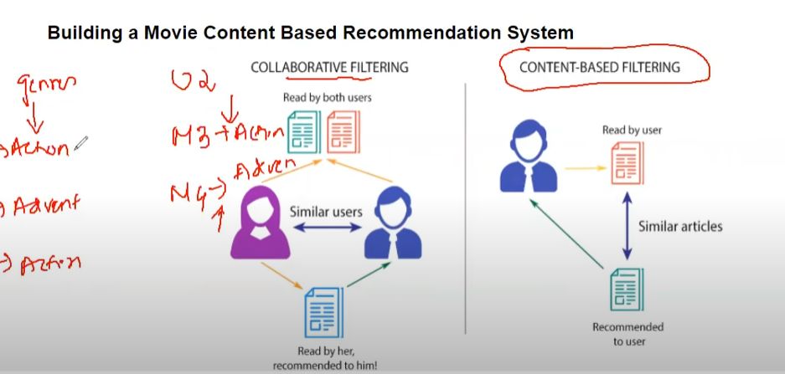

*Types of Recommender Systems:*

1. Content Based
2. Collaborative Filtering Based.
3. Hybrid

*Content Based Recommendation Engine:*

Content ke similarity ke base pe chize recommend karta hai.

E.g listening romantic songs then next type ke gaane bhi sbh romantic aayega.

*Collaborative Filtering*

*2 log Similar hai unke data ke hisabse,*

*Ankit bhai tuje pata hai yeah pehlese*

*Hybrid:*

*Hybrid means combination of both content & collaborative.*

*2-3 Saal pehle Youtube ka jo recommendation tha vo Content Based tha*

*But in recent years mai they have switched to hybrid based ( Content + Collaborative )*